תיק משתמש

CryptoPulse – B5 group

The first page (Home page):

Welcome page overview:

1. Login/Signup:

In the top right corner, users have the option to either 'Log in' or 'Sign Up.' This is designed to onboard new users and provide returning users with easy access to their accounts, which suggests that there are features beyond the public information that require user registration.

2. Language Selection:

Beside the login options, there is a language dropdown, indicating that the website is accessible to a global audience and supports multiple languages. This enhances user accessibility and convenience.

3. Theme Toggle:

While not explicitly visible in the image provided, if there's a theme toggle, it would typically allow users to switch between light and dark modes, catering to personal preference and offering a more comfortable viewing experience depending on the environment or time of day.

4. Bitcoin Halving Countdown:

An intriguing element on the page is the real-time countdown to the next Bitcoin halving event. It shows the exact time left down to the seconds, creating a sense of anticipation, and making the site feel dynamic and current.

Login page overview:

Here the user can login to his account, he can choose forget password option to reset his password.

Signup page overview:

In this page the user can signup a new account with a new password.

Homepage overview:

The page features a “Good Evening!” greeting which is dynamic, changing based on the time of the day. In the top corner, the user’s account is accessible, the language selection remains consistent, appearing in the same place as in the previous screens.

In the same page (Homepage), when you press user’s account, this menu which include navigation buttons: Coins, News, Transactions History, Dashboard, each button led to a different page which have its own functionality.

Coins page overview:

Here you can see a table which includes 100 cryptocurrencies and the information for each currency. In addition, there is a search bar which allows you to search for a specific currency.

News page overview:

This page shows the news for cryptocurrency by API that conduct fetch to cryptocurrency news. All news is up-to-date and relevant. This page also have a search bar that allows you to search for a specific news.

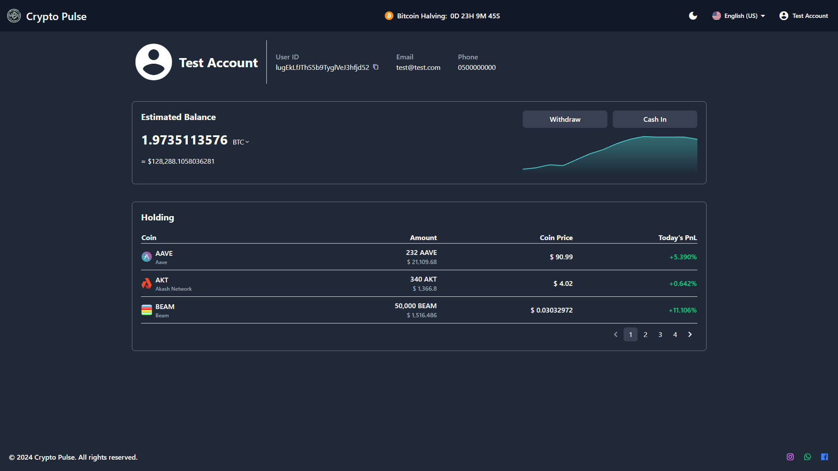

Dashboard page overview:

This page has all the information about your wallet, includes account balance which it displayed by 3 different values: Ethereum, Bitcoin, USD. The chart shows the account balance change. The table represents all the cryptocurrencies that the user has with the amount of each currency in your wallet.

The page also represents a general information about user account.

The page also allows users to go through 2 pages: Cash In page, and Withdraw page:

Cash In/Buy page overview:

In this page users can buy currencies.

Cash In/Trade page overview:

This page allows users to spend amount of currencies to get new currencies.

Withdraw page overview:

This page allows users to deposit currencies to bank account.

Transactions History page overview:

This page shows the user his transactions history. It shows Buy history, trade history and Withdraw history.

Profile Settings page overview:

This page allows the user to change profile settings, like username, password.